Introduction to ChatGTP Integration in RStudio
Abby Muricho Onencan
2024-04-01

Introduction to ChatGTP Integration in RStudio
Welcome to the “Introduction to ChatGPT Generative AI Integration in R Programming” course! This course is designed for beginners interested in integrating generative AI technology, particularly OpenAI’s GPT-3.5 and GPT-4 LLMs, into the R programming language ecosystem. Through interactive sessions, you’ll gain hands-on experience in using generative AI (ChatGTP) to enhance R coding proficiency and streamline data analytics workflows.
This course consists of three sessions:
- Session 1: Setup and Package “askgpt”and “air”
- Session 2: Exploring ChatGPT Tools for R
- Session 3: Enhancing Workflow with AI Assistants

1. Configuring OpenAI API Key
To utilize the default AI service from OpenAI, follow these steps
- Sign up here to create an OpenAI account and obtain an API key.
- Create an OpenAI API key to use with the ChatGPT sessions.
- Save the API key in RStudio in a text file.
- Note: Ensure valid payment details are entered into your OpenAI account for API functionality.

2. Generative Pretrained Model (GPT)
A Nested set of technologies from AI to transformers
ChatGPT falls under the group LLM known as transformers (Generative Pretrained Transformers)
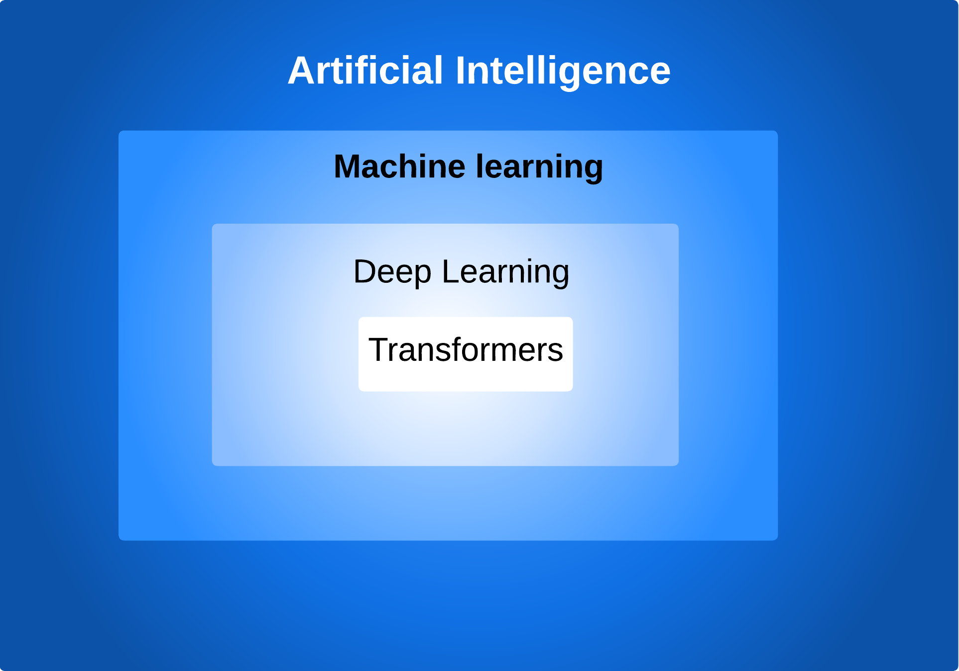
A Nested set of technologies from AI to transformers
Essential concepts for using OpenAI API
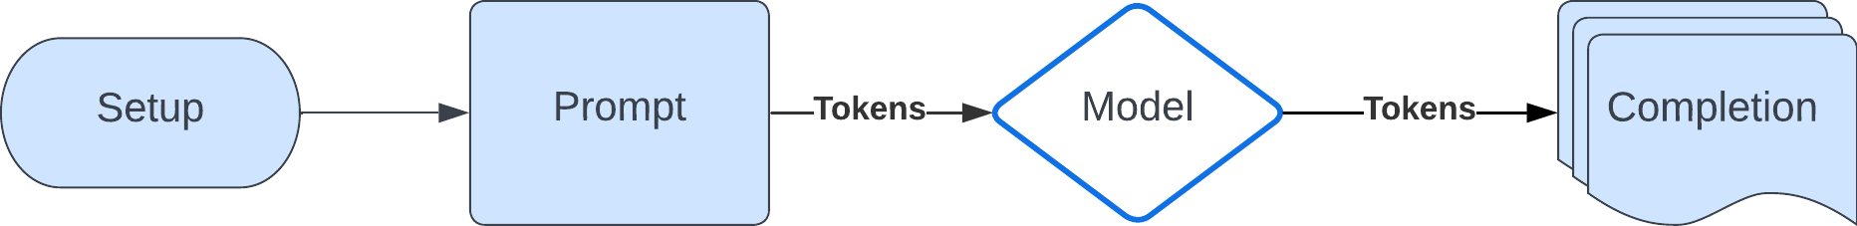
Essential concepts for using OpenAI API
- Prompt
  - The input text you put into the GPT models
  - Have a chat format
  - Input and output messages stored in a list
- Models
  - GPT-4 Turbo
  - GPT-4
  - GPT-3.5 Turbo (free)
  - Assistants API (Code interpreter and Retrieval)
  - Fine-tuning models (for creating custom models by fine-tuning base models)
  - Embedding models (advanced search, clustering, and topic modeling)
  - Base models (davinci-002 and babbage-002)
  - Image models (DALLB7E 2 and 3)
  - Audio models (Whisper for transcription / translation and TTS / TTS HD)
- Tokens
  - Words or parts of words
  - API requests paid based on the number of tokens (input and output)
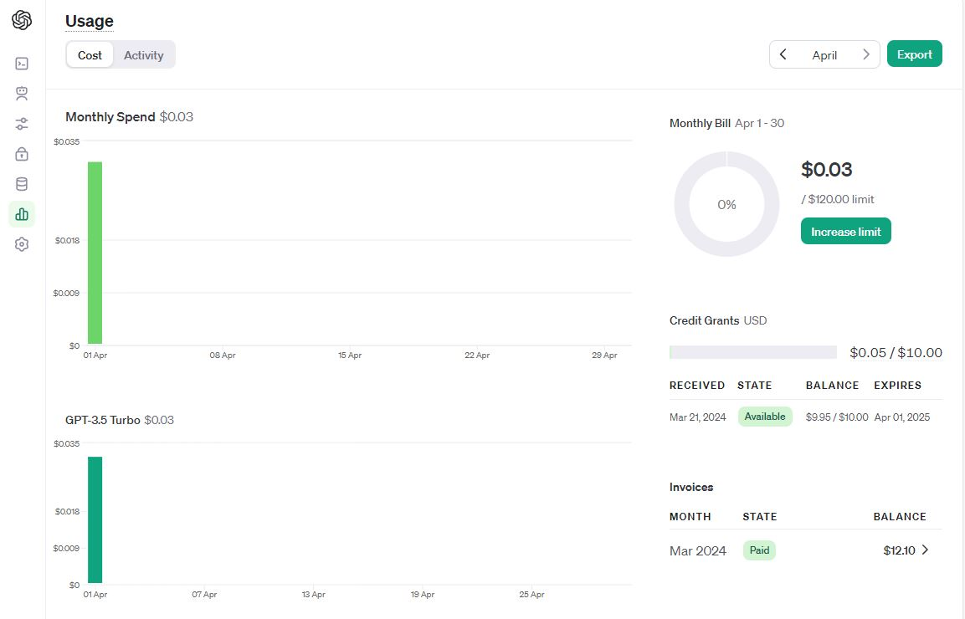
Tracking Monthly Usage

